Title: Political Party Differences in Language Use in Discourse on Conflict

Presenters: Kayla N. Jordan, Erin M. Buchanan, Jahnavi Delmonico, & Russell Carney

Abstract: When it comes to politics in the United States, the map is painted red and blue. Republicans and Democrats demonstrate linguistic differences in political and group words such as *citizen* or *constitution* (Jarvis, 2007), and use of moral words such as *harm* or *just* (Graham, Haidt, & Nosek, 2009). Further, Slatcher, Chung, Pennebaker, and Stone (2007) found that presidential and depressive language varied by political party. In the present study, we examined potential dissimilarities in linguistic usage by investigating how politicians from each party spoke about conflict with other nations, such as Iraq, Iran, North Korea, and Russia. Approximately 2500 language samples were obtained from the records of the Senate, House, and House/Senate Foreign Affairs Committees and were analyzed for linguistic categories with LIWC software (Pennebaker, Booth, & Francis, 2007). Multidimensional scaling analyses indicated that Democrats and Republicans show different clusters of concepts. Additional findings will be discussed.

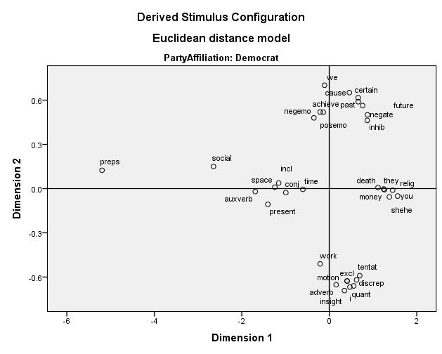

For matrix Stress = .21666 RSQ = .90226

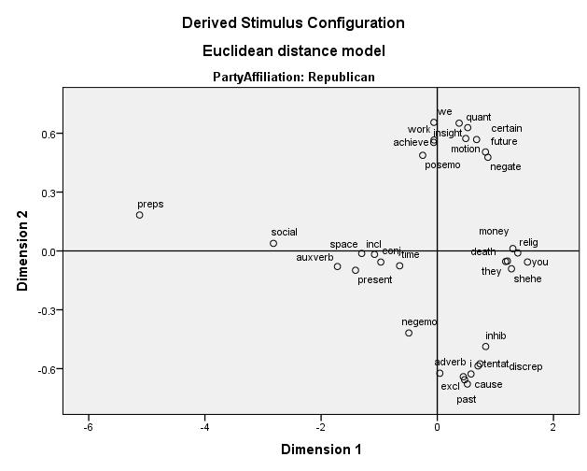

For matrix Stress = .21051 RSQ = .90836